**Assignment 2**

#Laboratory Exercise 5, Assignment 2

.data

Message1: .asciiz "The sum of "

Message2: .asciiz " and "

Message3: .asciiz " is "

.text

li $v0, 4 # service 4 is print string

la $a0, Message1 # the string to be printed is Message1: "The sum of "

syscall # execute

la $s0, 1 # $s0 = 1

la $s1, 2 # $s1 = 2

add $t0,$s0,$s1 # $t0 = $s0 + $s1

li $v0, 1 # service 1 is print integer

la $a0, 0($s0) # the interger to be printed is 0($s0)

syscall # execute

li $v0, 4 # service 4 is print string

la $a0, Message2 # the string to be printed is Message2: " and "

syscall # execute

li $v0, 1 # service 1 is print integer

la $a0, 0($s1) # the interger to be printed is 0($s1)

syscall # execute

li $v0, 4 # service 4 is print string

la $a0, Message3 # the string to be printed is Message3: " is "

syscall # execute

li $v0, 1 # service 1 is print integer

la $a0, 0($t0) # the interger to be printed is 0($t0)

syscall # execute

* ***Kết quả***

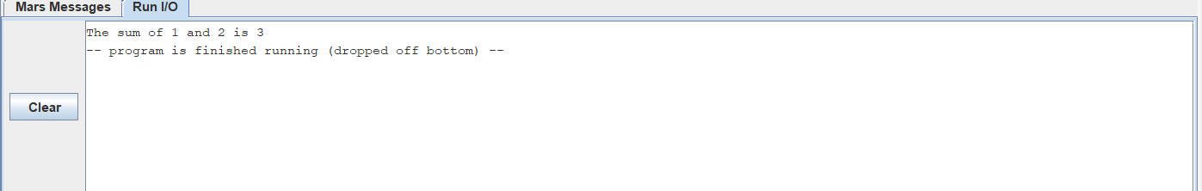

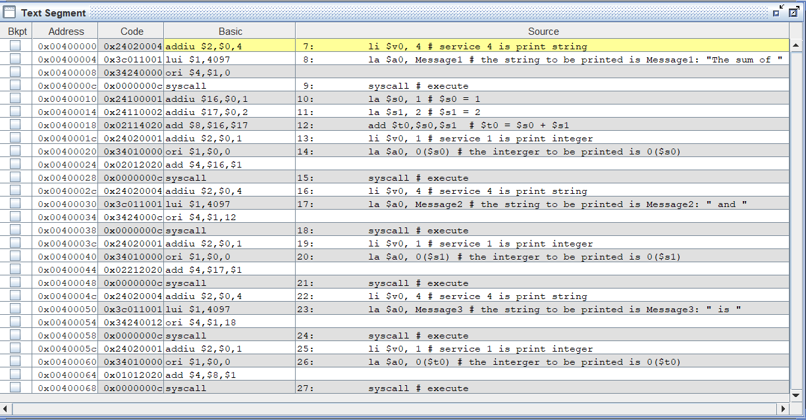

* **Bảng giá trị thanh ghi**

